Georgia Department of Behavorial Health and Developmental Disabilities
Regional Field Offices Phone numbers
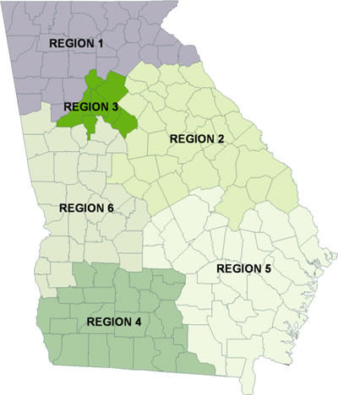
Region 1 Field Office serves the following 31 counties in North Georgia: 678-947-2818
Banks, Bartow, Catoosa, Chattooga, Cherokee, Cobb, Dade, Dawson, Douglas, Fanin, Floyd, Forsyth, Franklin, Gilmer, Gordon, Habersham, Hall, Haralson,Hart, Lumpkin, Murray, Paulding, Pickens, Polk, Rabun, Stephens, Towns, Union, Walker, White, and Whitfield.
Region 2 Field Office serves the following 33 counties in East Central Georgia: 706-792-7733
Baldwin, Barrow, Bibb, Burke, Clarke, Columbia, Elbert, Emanuel, Glascock, Greene, Hancock, Jackson, Jasper, Jefferson, Jenkins, Jones, Lincoln, Madison, McDuffie, Monroe, Morgan, Oconee, Oglethorpe, Putnam, Richmond, Screven, Taliaferro, Twiggs, Walton, Warren, Washington, Wilkes, and Wilkinson.
Region 3 Field Office serves the following 6 counties surrounding Metro Atlanta: 404-244-5050
Clayton, Dekalb, Fulton, Gwinnett, Newton and Rockdale.
Region 4 Field Office serves the following 24 counties in Southwestern Georgia: 229-225-5099
Baker, Ben Hill, Berrien, Brooks, Calhoun, Colquitt, Cook, Decatur, Dougherty, Early, Echols, Grady, Irwin, Lanier, Lee, Lowndes, Miller, Mitchell, Seminole, Terrell, Thomas, Tift, Turner, and Worth.
Region 5 Field Office serves the following 34 counties in Southeastern Georgia: 912-303-1670
Appling, Atkinson, Bacon, Bleckley, Brantley, Bryan, Bulloch, Camden, Candler, Charlton, Chatham, Clinch, Coffee, Dodge, Effingham, Evans, Glynn, Jeff Davis, Johnson, Laurens, Liberty, Long, McIntosh, Montgomery, Pierce, Pulaski, Tattnall, Telfair, Toombs, Treutlen, Ware, Wayne, Wheeler and Wilcox.
Region 6 Field Office serves the following 31 counties in West Central Georgia: 706-565-7835
Butts, Carroll, Chattahoochee, Clay, Coweta, Crawford, Crisp,Dooly, Fayette, Harris, Heard, Henry, Houston, Lamar, Macon, Marion, Meriwether, Muscogee, Peach, Pike, Quitman, Randolph, Schley, Spalding, Stewart, Sumter, Talbot, Taylor, Troup, Upson and Webster.

